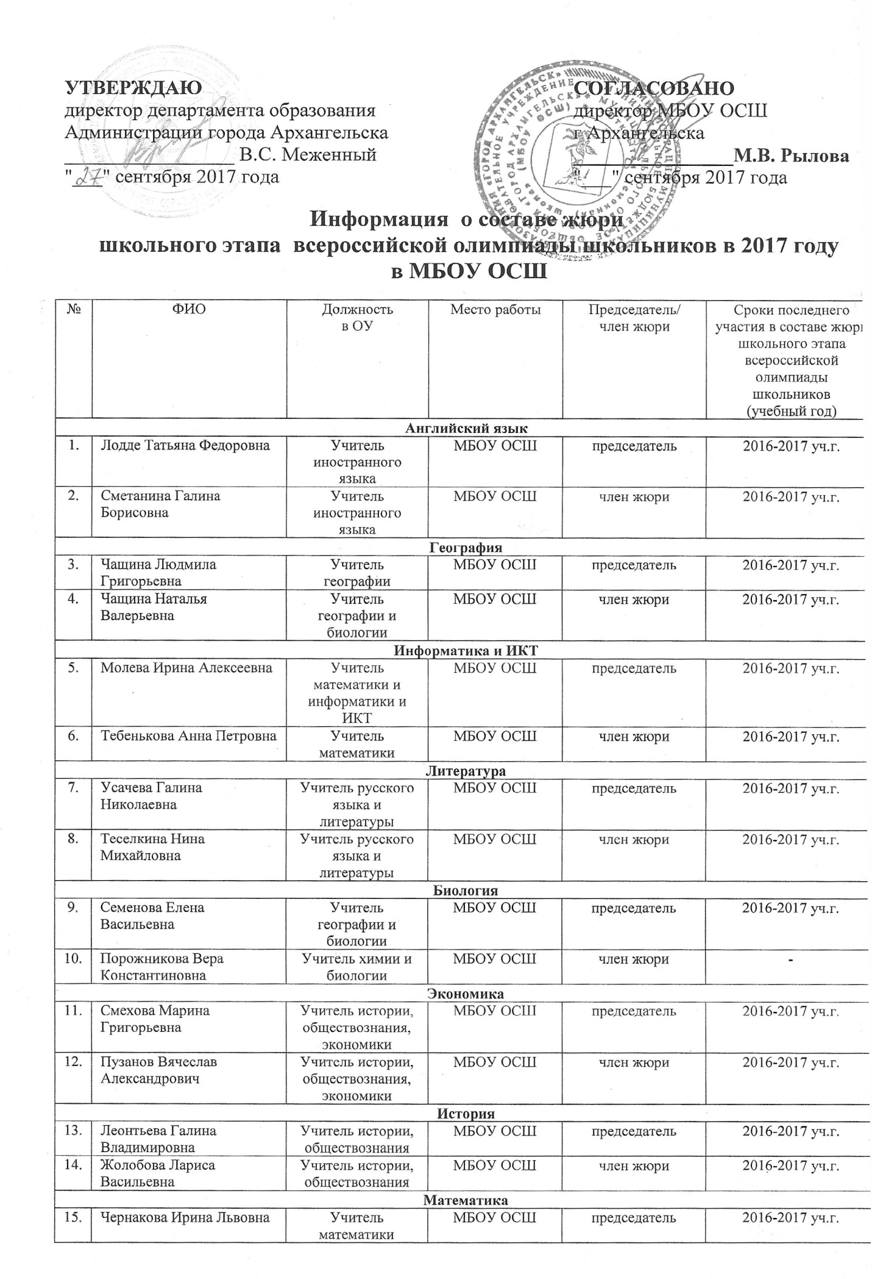

C:\Users\User\Desktop\3.tif